Pacific Regional Invasive Species Management Support Service
Protect our Islands Programme
Early Detection and Rapid Response Protocols for Cane Toads, Asian Toads, and other amphibians

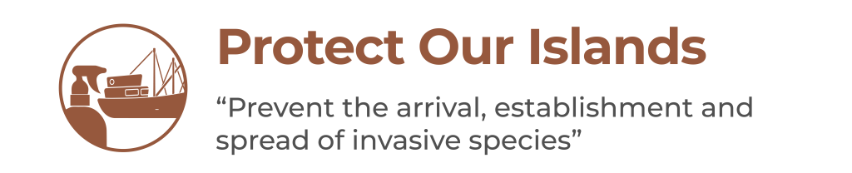



Contents
1 Acknowledgements 2
2 Introduction 3
3 PRIORITISE 5
3.1 Identify risk pathways for priority species 5
4 PREPARE 5
4.1 Define EDRRP area. 5
4.2 Decide on strategy 6
4.2.1 Evaluate Environmental impacts. 6
4.2.2 Equipment and supplies 6
4.2.3 Permits and permissions 6
4.2.4 Accountabilities and structure 6
5 DETECT 7
5.1 Active surveillance 7
5.1.1 Visual and Auditory Survey 7
5.1.2 Drift fencing and pitfall trapping 8
5.1.3 Detector dogs 10
5.1.4 Toadinator traps 10
5.2 Passive surveillance 11
5.2.1 Public awareness 11
6 RESPOND 14
6.1 Identification and humane euthanasia 14
6.1.1 Identification 14
6.1.2 Humane euthanasia 14
6.2 Delimitation and Containment 17
6.2.1 Drift fencing and pitfall trapping 17
6.2.2 Hand capture and removal 20
6.2.3 Citric acid solution spray 21
6.2.4 Tadpole trapping 23
6.2.5 Toadinator trap 26
6.2.6 Removal of waterbodies 27
6.2.7 Detector dogs 27
6.3 Eradication strategy 27
6.4 Data management and reporting 27

Acknowledgements
These protocols were developed by James Reardon of the New Zealand Department of Conservation.
Development of the cane toad protocols was funded by the New Zealand Ministry for Foreign Affairs and Trade under the Managing Invasive Species for Climate Change Adaptation in the Pacific (MISCCAP) project.

The EDRR framework was developed for the Protect our Islands programme by Pacific Biosecurity under the Regional Invasives Project (GEF 6 RIP) - Strengthening national and regional capacities to reduce the impact of Invasive Alien Species on globally significant biodiversity in the Pacific. The GEF 6 RIP is funded by the Global Environment Facility (GEF), implemented by the United Nations Environment Programme (UNEP), and executed by the Secretariat of the Pacific Regional Environment Programme (SPREP).



Introduction
These protocols should be read in conjunction with the country EDRR plan. The protocols provide the technical information needed to conduct EDRR and are generally structured based on the EDRR checklist: PRIORITSE, PREPARE, DETECT, RESPOND.
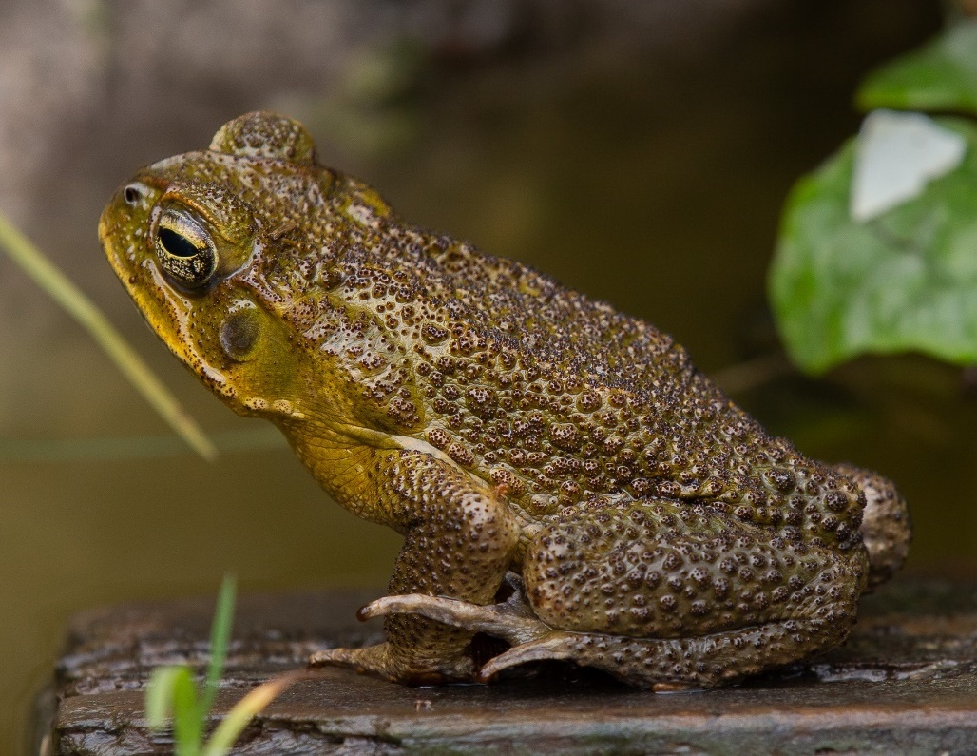
  - Fig.1. Cane toad (Rhinella marina) male in breeding pool, Funafuti, Tuvalu.
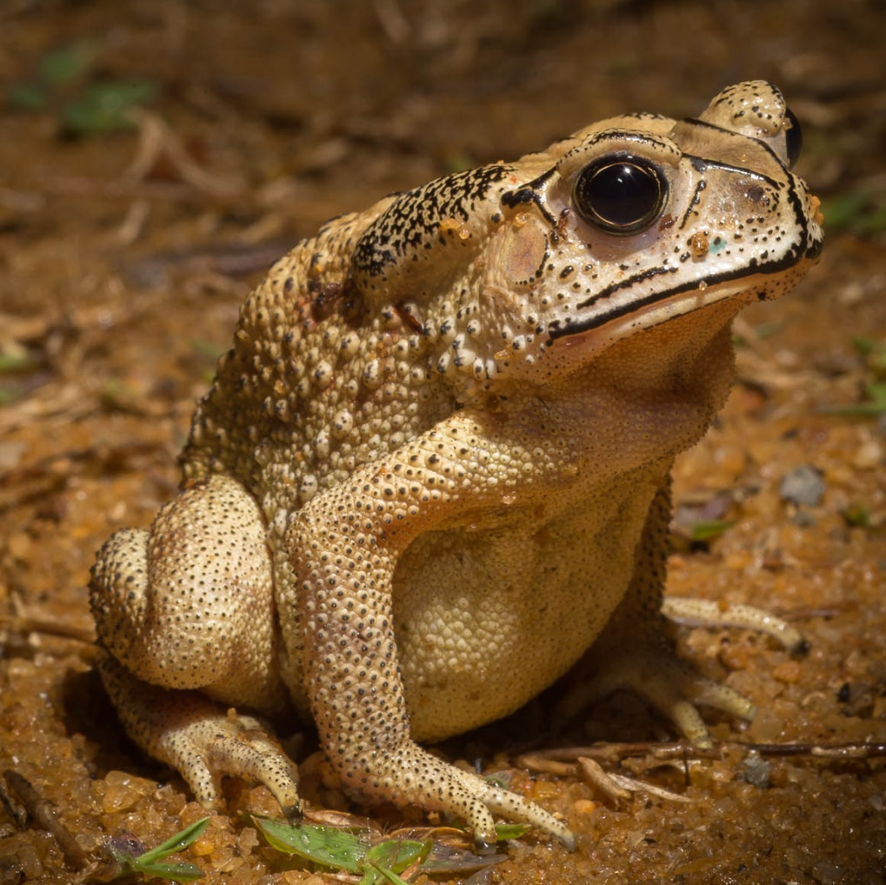
  - Fig. 2. Asian toad (Duttaphrynus melanostictus) also known as Asian common toad, Asian black-spined toad, black-spectacled toad, common Sunda toad, and Javanese toad.

PRIORITISE
In this section we identify the risk species and pathways.

Identify risk pathways for priority species
Pathways depend on transport and trade routes. All freight, shipping and aircraft arriving from a location or having travelled via a location known to be occupied by cane toads or Asian toads should be regarded a priority.
Cane toads and Asian toads can be considered as identical risks as the two invasive species are extremely similar in both their ecology and likely impacts. Cane toads are widespread across several Pacific Islands already, so they have a more proximate diversity of potential sources. Asian toads are abundant in Southeast Asia and so their potential to spread via trade is perhaps less than cane toads but is still significant.
Highest risk pathways are containers and large mechanical equipment or construction supplies. These sorts of freight are likely to have spent extended periods pre-shipping in open storage where toads can find refuge. Agricultural and mining equipment may be especially high risk, the latter being implicated in the introduction of Asian toads to Madagascar.
SOURCES:
CABI. 2019. Horizon Scanning Tool. Crop Protection Compendium. Wallingford, UK: CAB International. https://www.cabi.org/cpc.
Niue: Compilation and Review of Invasive Alien Species Information for Niue. Shyama Pagad, Invasive Species Specialist Group (ISSG) Pacific Regional Office. September 2013
Republic of the Marshall Islands: Report for the Secretariat of the Pacific Regional Environment Programme (SPREP). Compile and Review Invasive Alien Species Information for the Republic of the Marshall Islands. Shyama Pagad, Biodiversity Data Management Ltd. Programme Officer, IUCN SSC Invasive Species Specialist Group. March 2015
Kingdom of Tonga: Comprehensive Desk-top Review of Biodiversity, Conservation and Invasive Species Information for the Kingdom of Tonga. Compiled for the Secretariat of the Pacific Region Environment Programme (SPREP). Shyama N Pagad, Programme Officer IUCN SSC Invasive Species Specialist Group/ University of Auckland, March 2013
Tuvalu: Baseline Desktop Invasive Species and Biodiversity Study. Shyama Pagad, November-2019

PREPARE
In this section:
- Ensure all needs for surveillance and response are in place
  - Define EDRRP area
  - Decide on strategy

Define EDRRP area.
Focus EDRR planning and action on the EDRRP area (where the species is most likely to arrive). Identify risk entry points, such as arrival and unloading facilities, for ongoing surveillance and potential incursion sites.
While we can't predict where invasive species will show up, we can boost detection likelihood by understanding their likely arrival points and maintaining regular surveillance there. Creating an EDRRP area based on entry point knowledge and risk assessment helps estimate Rapid Response needs and sets the zone for active surveillance.
Pinpoint the highest-risk entry point through pathway analysis. For international biosecurity, this is typically the primary port; for interisland biosecurity, it's the main entry point at the target site.
Mapping using GPS tools to map EDRRP area boundaries and key locations, to enable an estimation of effort and resources needed to maintain surveillance.
The frequency of surveillance will be dictated by risk and resource capacity. Failure to achieve early detection will increase the rapid response costs exponentially.

Decide on strategy
It is necessary to clearly define the intended goals of the work. The optimum and usually preferred strategy for any incursion of a new invasive species is to eradicate the pest, learn about pathways leading to the incursion and improve biosecurity to reduce risks of future incursions. For instances where eradication is either not feasible or not desirable, sustained control of the invasive pest is the next option. Whilst less costly and complex than an eradication, control, by its nature requires on-going investment and effort. When control measures are stopped the benefits of previous control will be quickly lost.

Evaluate Environmental impacts.
Before planning the work, it is important to understand the environmental impacts of the proposed tools and to ensure that there are no unacceptable non-target issues. This includes concerns that eradication or control methods could harm native wildlife, livestock, people, or plant. Fortunately, most of the tools suitable for addressing invasive amphibians are non-lethal meaning field workers can release any non-target species.
The one tool that does raise concerns is the use of citric acid spray. This tool is non-selective amongst amphibians and so it’s use needs to be strategies to ensure that any native amphibians are managed accordingly. For an incursion of species such as cane toads or Asian toads, which are known to cause serious direct impacts on wildlife this means that there may be justification for local impacts on native amphibians if the goal is eradication and those native amphibians are not put at threat of extinction using the tool.
Citric acid solution has the potential to be phytotoxic (damaging to plants). Therefore, if it is to be used in extensive areas of native vegetation, in areas of crops or in areas containing threatened plants, it is essential that first a phytotoxicity trial is conducted. This would require that small, marked patches of the vegetation are sprayed with quantities of the solution in the same manner that toad habitat would be. Those marked patches are then monitored every two days for 8 days and data is recorded on signs of leaf burning, plant bleaching or plant death. An informed assessment of results will determine whether the citric acid treatment is suitable for use in the incursion environment or portions thereof.

Equipment and supplies
In remote locations it may take time to gather the necessary tools and equipment. At the first opportunity, once a strategy has been developed and agreed, it is necessary to assemble all tools and equipment required, including adequate consumable materials to cover at least the first season’s worth of effort.

Permits and permissions
Prior to developing an operational plan for the eradication or control of invasive species it is necessary to get all necessary permissions to access all areas of the operational area. In eradications it is a pre-requisite that all areas occupied by the pest species are accessible for the use of sufficient tools to ensure eradication is possible.

Accountabilities and structure
Before operationalising a response operation to eradicate an invasive population there must be agreement on a clear set of accountabilities to both responsible agencies and individuals. Whilst support from authorities will be necessary it is vital that project accountability sit with someone with expertise not only in administration but also the operational needs of the project. Where capacity allows, the components of the project should be clearly delegated to ensure capacity is used to maximal efficiency.

Expert technical advisory group (TAG)
The purpose of this information is to empower within country capacity to plan and deploy their own response to a pest incursion. Eradication of invasive amphibians is still a very new area of work and so there is only limited information in the literature to support planning. There are, however, a small but growing number of managers and scientists globally that are engaged in amphibian eradication or control and if possible, the accountable manager of the project should seek to develop correspondence with those engaged in the field internationally. Where capacity allows, this is best done through the development of a Technical Advisory Group (TAG) with whom project planning documents can be reviewed and improved.

DETECT

Active surveillance
Early detection of invasive toads requires active and on-going surveillance. The resolution and frequency of this effort will determine the sensitivity and therefore the probability of early detection if an incursion happens. There are several tools and techniques that can be employed, and these are listed below:

Visual and Auditory Survey
It is first important to be familiar with Asian and cane toad appearance (Fig. 1 & 2). These toads are distinctive as large robust amphibians with warty skin. Both species have large glands (parotid glands) behind each eye which is an area of toxin secretion. Asian toads can easily be distinguished from cane toads by the presence of black ridges on the head and often also have black markings on the ‘warts’ that cover the majority of their dorsal (back) skin.
Both Asian and cane toads are mostly crepuscular (active at dusk and dawn) and both species are happy to use anthropogenic environments such as urban and agricultural habitats with a preference for disturbed habitat. As such they will occupy areas where people re regularly present and both species are commonly active in areas where people are also active, making them easy to spot. Adult toads of both species are usually around the size of a tennis ball and so easily spotted. Juveniles and metamorphs (young froglets) are much smaller so less easily observed.
Searching the edges of cover such as the edges of taro plantations, floor guttering around houses and habitat surrounding standing waterbodies with a head torch during dusk will provide the best probability of detection. If searching during daylight hours, it may be necessary to disturb potential cover such as timber or refuse piles in which toads may be sheltering.
Waterbodies can be searched for signs of eggs or tadpoles. The eggs of both cane toads and Asian toads are long strings of eggs (Fig. 3).
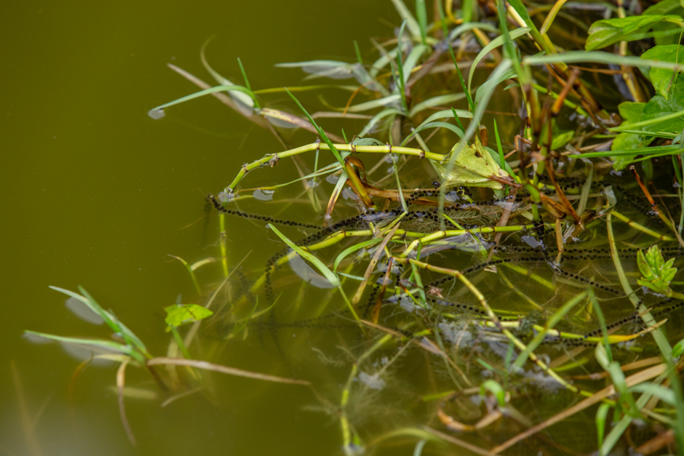
  - Fig. 3. Cane toad eggs at breeding pool near Pulaka pit, Funafuti, Tuvalu.
Once hatched the eggs become tadpoles with are small black tailed animals initially less than a centimetre long but growing up to 2.5cms within several weeks, whereupon they develop legs and then metamorphose (transform) into tiny toadlets of less than a centimetre long.
Toads may also be detected by listening for their calls. Both have a distinctive call especially so in environments with limited or no other amphibian or night calling species. The cane toad has a softer trilling call compared to the Asian toads squeaky trilling call:
Cane toad call: https://www.youtube.com/watch?v=2BAKkyxXA1w
Asian toad call: https://www.youtube.com/watch?v=bIO4qh5JSbQ
Toads usually call from in or adjacent to breeding waterbodies so locating toads that are calling should raise the possibility that the toads are breeding in nearby waterbodies.

Drift fencing and pitfall trapping
Toads are moderately mobile animals but not excellent climbers. Therefore, a fence placed into their habitat will act as a barrier. Any toads in the area encountering the barrier fence will move along the fence, hence such fences are often called ‘drift fences’ by those using them to study wildlife.
To work properly, drift fences need to be dug into the substrate to a small depth sufficient to prevent toads from pushing beneath the fence material. Materials can be light plastic sheeting or weed matting for short to medium term use (Fig. 4.), but heavier duty plastic or metal sheeting may be necessary for more permanent structures (Fig. 5.).
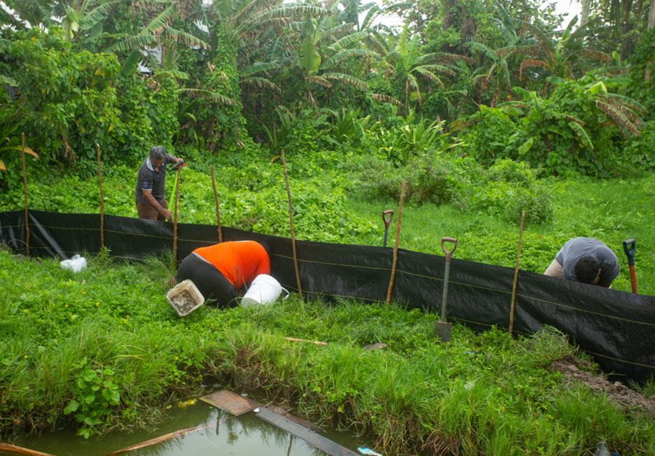
  - Fig. 4. A section of cane toad drift fencing, Funafuti, Tuvalu constructed of weed matting and locally harvested wooden stakes. The weed matting is dug into the ground to a depth of about 15cms and the material stapled to the wooden stakes.

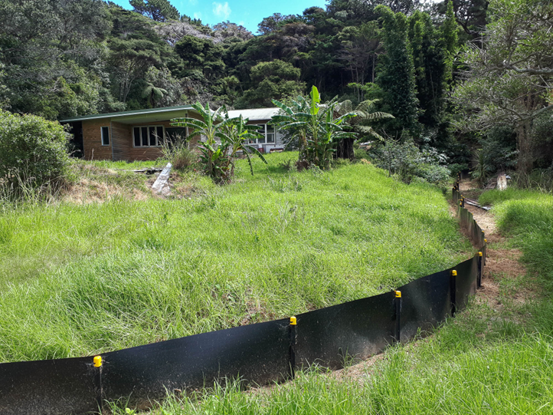
  - Fig. 5. Drift fencing made of 1.5mm thick HDPE (high density polyethylene) for a long-term containment fence for invasive skinks in New Zealand.
To detect toads, these drift fences need to include pitfall traps (Fig. 6.). These are simply buckets or similar containers sunk into the ground immediately adjacent to the fence. It is critical for their efficacy that they are placed immediately against the line of the fence in such a way that toads cannot sneak between the fence and the bucket without falling into the bucket.
For cane toads and Asian toads, the buckets need to be at least 50cms deep to prevent large animals escaping by hopping out. Buckets will also need holes to allow rainwater to drain away. Ground water is liable to flood into traps if placed at or below the water table. In some habitats this may mean that fences and pitfall traps will need to me placed on mounds or natural rises in the environment.
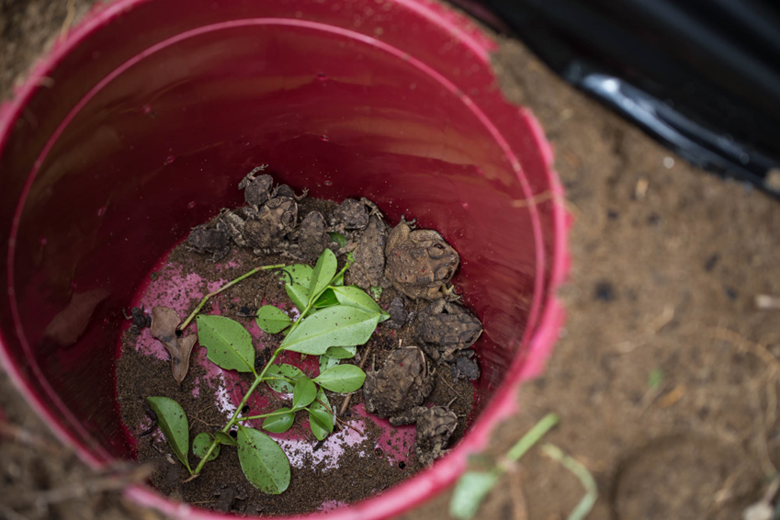
  - Fig. 6. Pitfall bucket trap with Asian toads captured in Madagascar. Note the black plastic of the drift fence.
Pitfall traps need to be checked daily whilst active and all captured animals dealt with appropriately. More details of the use of drift fences and pitfall traps are provided in section 6.2.1 below.

Detector dogs

Dogs specially trained to find and indicate cane toads or Asian toads could be a very effective detection tool but there are very specific requirements and considerable time and expertise required to develop competency in both dog and handler. There are commercial providers of detector dogs and government agencies like New Zealand’s Department of Conservation have pest dog training programmes. These sources of support or expertise may be accessible to a project if resources are also available.

Toadinator traps
Cane toads are attracted to both toad calls and invertebrate prey. This provides an opportunity for the development of toad lures that can be integrated with a trap. The Toadinator is a cage trap designed specifically for the effective capture of cane toads (Fig. 7).
On three sides, the cage has specialised one-way finger doors that allow toads to enter but not exit. The Acta-Attracta is an electronic lure designed to bring toads to the trap. The lure has an inbuilt UV light that attracts insects, which in turn attracts toads, because insects are a favoured food source.
The lure also has a sound component which comes pre-loaded with cane toad calls. These calls are specific to cane toads and are demonstrated to be attractive to females. The solar powered lure has onboard power storage, so an external power source is not always required. It turns on at night when toads are active but is off during the day. The lure has a volume control which is important in residential areas.
The lure provides calls specific to lure female toads is the key to the success of the Toadinator. James Cook University in Australia researched male cane toad calls, and identified what made their calls attractive to female toads. During trials, capture rates increased 10-fold when calls were used in combination with light and sound. Calls with specific features were found to be best for removing females, and it is important to remove female toads from the population because fewer eggs will be laid for future generations. The pre-recorded toad calls are selected to maximise luring of both sexes. Toads are attracted by the sound and by the insects that are attracted to the light.
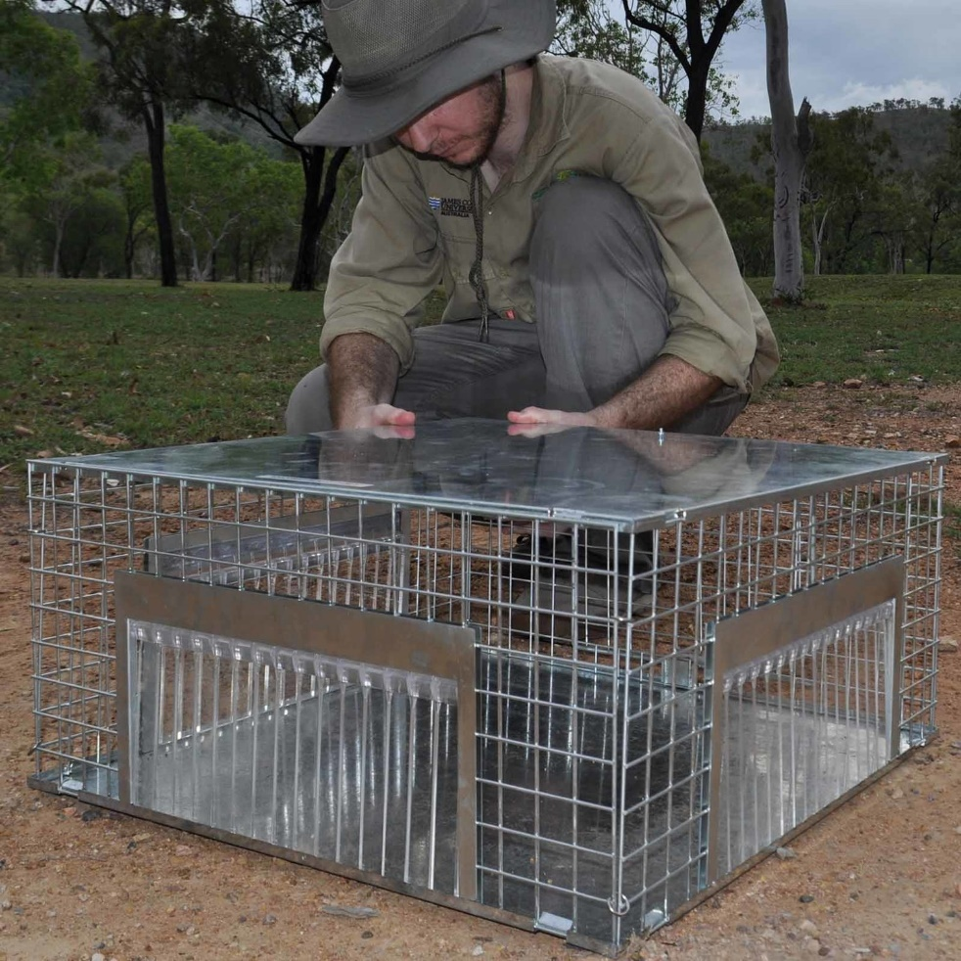
  - Fig. 7. Toadinator trap being assembled (https://animalcontrol.com.au/products/toadinator)
The Toadinator trap comes with instructions and tips on optimal use. They may serve as a cost-effective surveillance device if regularly operated at sights of potential incursion.
Equipment required:
Toadinator trap https://animalcontrol.com.au/products/toadinator
Health and safety:
None regarding the trap and standard precautions for handling and euthanising toads.

Passive surveillance
Active surveillance requires that devices or actions are taken to detect toads but there is also a more passive surveillance method.

Public awareness
Information identifying the invasive toads needs to be provided to the general population along with information to identify the toads, and their status as an unwanted organism which should be reported to the relevant authorities if sighted. Ways to spread such information will vary from location to location and will always need to be tailored to the local needs. It is especially important that risk to public health and livestock are clearly described.
An example of materials prepared for local translation for the Tuvalu community is provided below where toads are already present and established but uncertainly about their impacts are common:
Cane toad facts for the Tuvalu community
Prepared by: Dr James T. Reardon, Department of Conservation (NZ) August 2023.
Objective: to provide useful information to a non-technical audience to help them understand the risks posed by cane toads and some simple measures to reduce their abundance around dwellings.
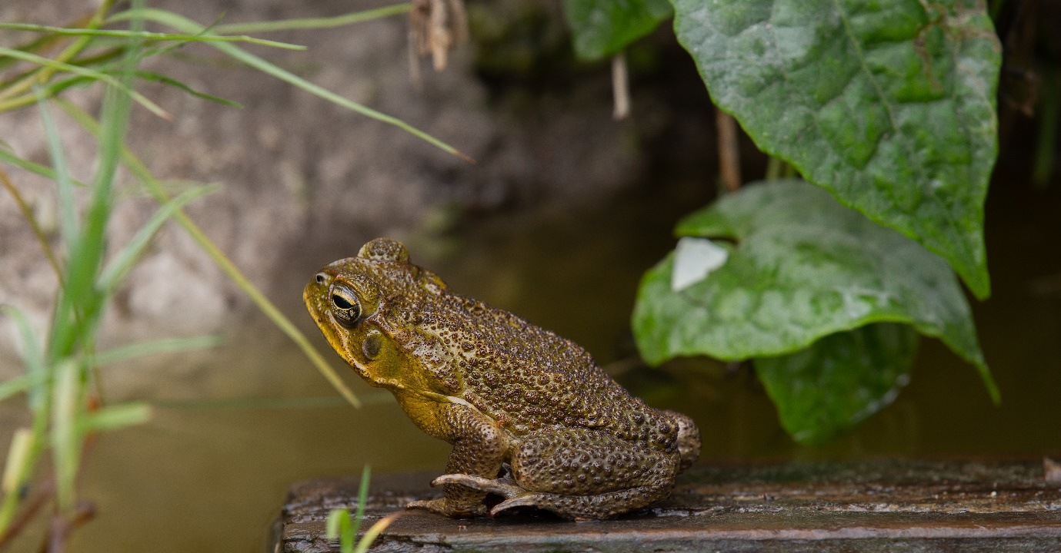
  - Cane toad eggs at breeding pool near Pulaka pit, Funafuti, Tuvalu. Yellow oblong identifies the parotoid gland behind the eyes that contains most of the toads’ toxins.
Cane toads, what are they? Cane toads are an invasive species. They are originally from central South America, introduced to Australia to control cane weevil. The toads were a failure as a biocontrol agent but before this was learned they were spread across many of the Pacific islands. They are amphibians so need access to fresh or brackish water to lay their eggs. Those eggs (strings of jelly with black embryos) hatch into tadpoles. These tadpoles can change (metamorphose) into toadlets in as little as 12 days.
Are the toads toxic? The toads are toxic at all life history stages (eggs to adults), but it is important to understand more about the nature of their toxicity to understand their threat to people. They have glands in their skin, including two large glands (parotoid glands) behind the eyes which contain the toxins.
Are toads dangerous to animals and people? Ingestion of the toxin can cause rapid heartbeat, convulsions, and paralysis. In animals that eat the toads, the toxins can be lethal. This is why the cane toads have had a serious impact on native wildlife in Australia. However, all these impacts require that the toad is licked or eaten. None of these effects can be caused merely by bathing or drinking water in which toads have been present.
Cane toads are toxic to dogs and pigs so neither should be fed cane toads or encouraged to interact with them.
What are the risks for children? The most serious risk of cane toads to human health is the risk to toddlers and small children who may be tempted to put toads in their mouths. As such, children should be advised to not play with cane toads. They should also be discouraged from attempting to hurt or kill toads. The reason for this is that the toad toxins are a defence mechanism and whilst a toad gently handled will not release toxins, if toads are hurt or threatened, they can expel their toxins from the parotoid glands.
What effects do cane toads have on the environment? Cane toads are predators of smaller animals. In places where they become super abundant, they will have an impact on other species or smaller animals through both predation and competition, where they may compete for food or refuge. This means it is possible that cane toads could reduce the abundance of species such as land crabs.
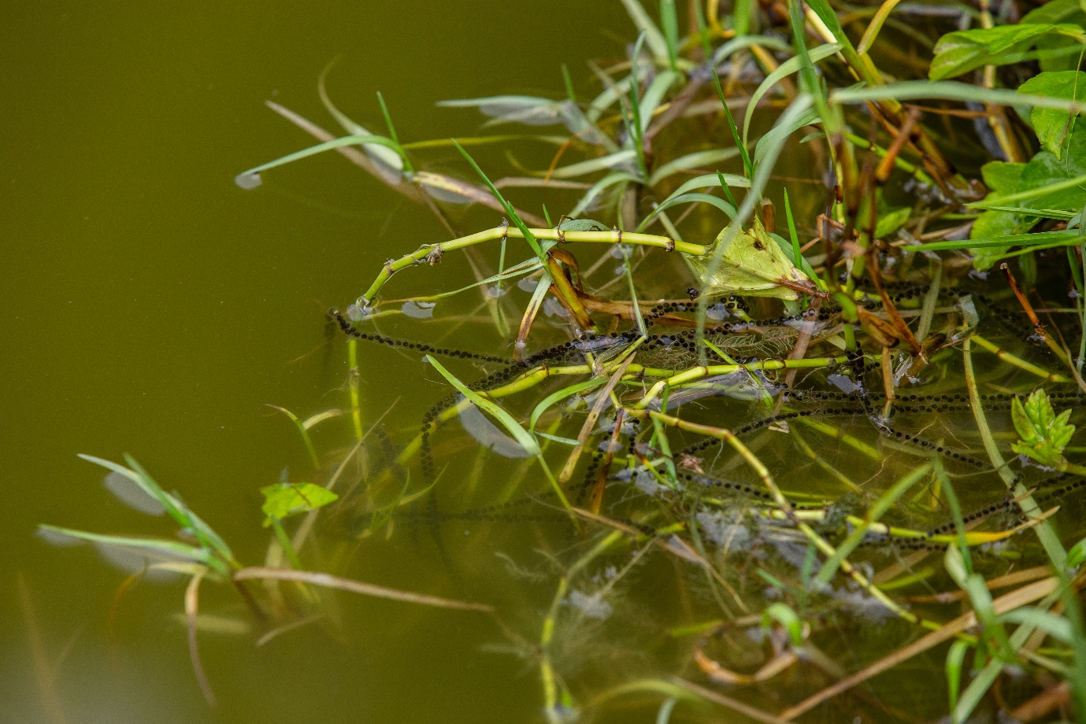
  - Cane toad eggs at breeding pool near Pulaka pit, Funafuti, Tuvalu.
How can we reduce the numbers of cane toads in Tuvalu? Cane toads require standing water for laying their eggs. These waterbodies must persist for at least two weeks for the tadpoles to metamorphose (change) into little toadlets. Any waterbody that is fresh or brackish that is standing for this period or longer is a potential breeding site for cane toads. Because of this, if access to water can be removed or minimised for toads this will reduce their numbers dramatically over time. Therefore, if temporary and non-essential waterbodies can be removed through filling in or aiding their drainage, breeding opportunities for toads will be reduced. Any depressions that regularly fill with rainwater and which are not needed, should be filled in. Reducing unnecessary standing water will also reduce breeding opportunities for other undesirable species like mosquitos. In Tuvalu it seems likely that Pulaka pits are a major source of breeding habitat for cane toads. These cannot be removed as they are required for food, but toads can be prevented from accessing these areas with the use of a low barrier fence of >50cms height.
Cane toads rely on piles of vegetation, rubbish, or discarded materials to survive the heat of the day. These retreats can be reduced through the removal of unnecessary vegetation, rubbish, or decaying materials. The removal of food waste or rubbish also diminishes the source of invertebrates which are prey for the cane toads. A clean and tidy garden will harbour fewer toads than a messy garden.
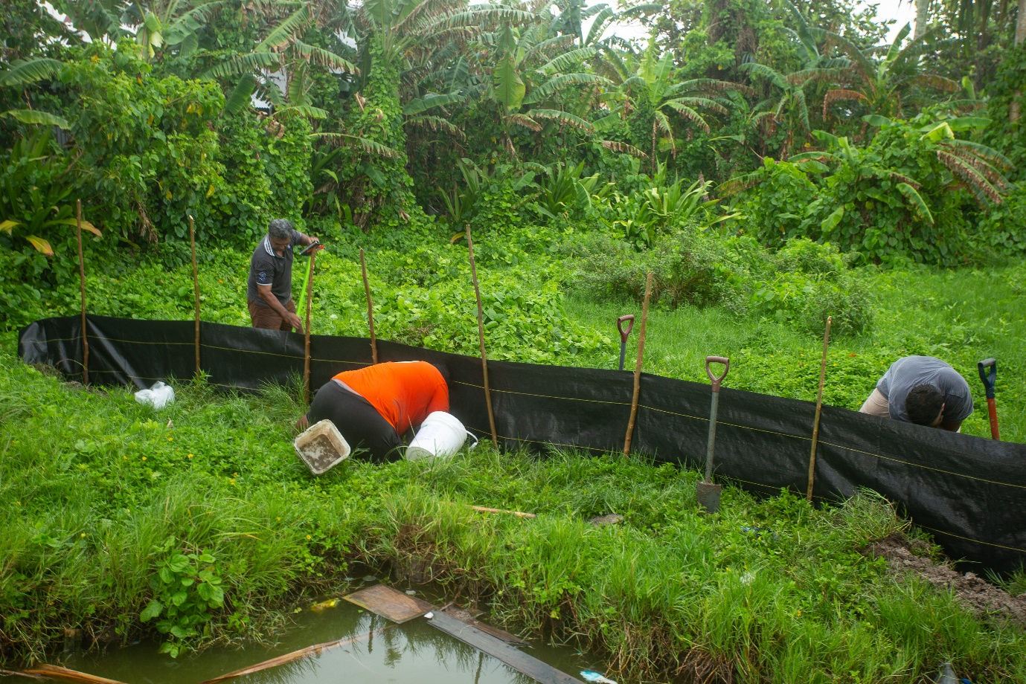
  - A demonstration section of cane toad exclusion fencing, Funafuti, Tuvalu.

RESPOND

Identification and humane euthanasia

Identification
Identification of cane toads or Asian toads is easy especially in locations with no other native or introduced frogs. Both species are warty frogs that can approach 15cms in length, occasionally larger for cane toads (Fig. 1 & 2). They are brown or olive green, cane toad juveniles can have strong pale and dark markings that fade with age. Asian toads are characterised by the black ridges on their head which are often accompanied by black dots on each wart. Both species have large parotid glands behind the eyes (Fig. 9).

Humane euthanasia
Irrespective of the fact that cane toads are considered pests, they are also capable of experiencing pain and distress and so any measures to control them must not cause suffering. It is the responsibility of both governments and the community to ensure that only humane methods are used.
There are two methods of euthanasia best suited for control or eradication efforts that are dealing with large numbers of toads:
- Cooling then Freezing

- Cooling then freezing is a method often advocated for the euthanasia of reptiles and amphibians (Shine et al. 2015), although there is not universal approval of its use (AVA 2007).
- This technique requires access to refrigeration and freezers. The method requires that toads are placed into suitable container (plastic tub) and then into a refrigerator with a temperature of 4°C for 12 hours. Once the toads are chilled and torpid, they are then transferred to a freezer (preferably -20°C) for at least 24hrs.
- This technique is not suitable for locations without refrigeration or power.
- An advantage of this technique is that it that it does not require the skilled handling or manipulation of the toads.
- Carcasses can be disposed of by deep burying or burning. Carcasses are toxic to animals, so it is important that they are prevented from being dug up by pigs or dogs.
Equipment required:
- Access to refrigeration and deep freezer.
- Plastic tubs or boxes into which the toads are placed.
Health and safety considerations:
- If gloves are not used when handling toads, then hands must be washed immediately afterwards.
- It is prudent to wear eye protection (face shield, safety glasses or sunglasses) to prevent the parotid secretions from entering eyes, although risks are low if toads are handled gently.

- Stunning followed by decapitation.

This method requires a level of handling skill and the use of tools that require care. The technique requires:
- experienced and skilled persons.
- the animal is held by the back legs against a solid surface.
- a large headed hammer is used for stunning.
- correct stun placement and stun force is used; and
- the toad is promptly decapitated with a sharp knife or cleaver.
- Carcasses can be disposed of by deep burying or burning.

Stunning (blunt trauma or cranial concussion) followed by decapitation is an effective and humane method that is recommended for the euthanasia of amphibians (AVMA, 2007). When performed correctly, stunning is sufficient to render the animal insensible (Close et al. 1996). Decapitation, which involves severing the neck of the animal close to the head using a sharp instrument, is then used to ensure death of the stunned animal.
Using a hammer, apply a forceful blow to the middle of the head just behind the eyes (see diagram in Fig. 9.). Immediately after delivering the stun, use the knife to decapitate the head. Cut in a line just behind the skull and lower jaw bones (see diagram in Fig. 1). These can be felt by following back along the jaw line until the bone turns inwards. Caution must be taken as this line runs through the toxin glands and toxin may be forced out during cutting (especially if the knife is not sharp).
Animals must always be stunned or rendered insensible prior to decapitation. Operators using this method must be skilled in its use and confident enough to deliver a blow of sufficient force and accuracy to render the animal immediately insensible.
Stunning must be conducted so that the cane toad is securely held against a solid surface that will not move or compress during the stun impact (or example, a chopping board on a table or the tray of a utility vehicle). If conducted against a softer surface (for example, on the ground) the animal may not be rendered immediately insensible.
Stunning must be conducted in a manner which maximises its effect thus causing rapid death. This requires the use of appropriate stun placement (to the region of the head between and just behind the eyes) and appropriate tools. A large headed metal hammer should be used to stun. Only head (brain) stuns must be used. Stunning or hitting any other parts of the body is NOT acceptable. Likewise for decapitation, only the head must be removed.
The stun and decapitation of single animals must occur before moving on to the next animal. It is NOT acceptable to stun multiple animals first and then decapitate them later. Toads will suffer if they have been stunned but not killed and they may regain consciousness before being decapitated.
Equipment required:
- A large hammer with a flat, metal head, or equivalent should be used for stunning.
- A rigid wooden or plastic chopping board (approximately 30 x 20 x 2.5 cm), or equivalent.
- A large, sharp machete or cleaver, for decapitation. Chainmail glove will reduce risk for less skilled operators.
Health and safety:
- If gloves are not used when handling toads, then hands must be washed immediately afterwards.
- When toads are stunned with a blow to the head, the toxin (parotid) glands (situated just behind the head) may rupture and spray toxin. Operators should use a face shield or sun/safety glasses in combination with face mask to avoid getting toxins in their eyes, mouth, and nose.
- Care must be taken when stunning toads with a hammer as there is a risk that operators may strike a thumb or fingers.
- Working with sharp tools can be dangerous, when decapitating toads, a chainmail glove is advised.

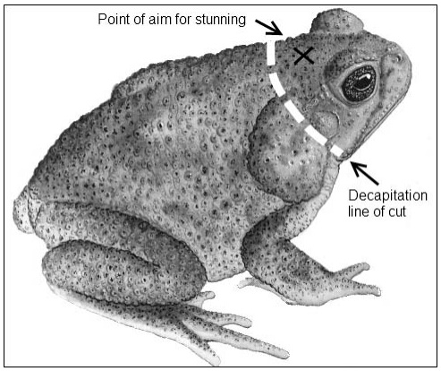
  - Fig. 9. Cane toad with strike point for stunning with a hammer (X) and the cut line for decapitation (broken white line). Orange line outlines the parotid gland where most toxins are held. Adapted from RSPCA.org.au
References for euthanasia:
American Veterinary Medicine Association (AVMA) (2007). The American Veterinary Medicine Association Guidelines on Euthanasia. Available at: http://www.avma.org/issues/animal_welfare/euthanasia.pdf
Close B, Banister K, Baumans V, et al. (1996). Recommendations for euthanasia of experimental animals: Part 1. Laboratory Animals.;30(4):293-316. doi:10.1258/002367796780739871 https://journals.sagepub.com/doi/abs/10.1258/002367796780739871
Shine, R., Amiel, J., Munn, A. J., Stewart, M., Vyssotski, A. L., & Lesku, J. A. (2015). Is “cooling then freezing” a humane way to kill amphibians and reptiles? Biology Open, 4(7), 760-763. https://research-management.mq.edu.au/ws/portalfiles/portal/99879468/99693300.pdf

Delimitation and Containment

Drift fencing and pitfall trapping
One of the most effective ways to reduce an areas cane toad population is through fencing and pitfall trapping. The purpose of a fence is to create a barrier that is very difficult for the cane toads to cross. This fence has the effect of channelling moving toads along its path. If pitfall traps are then installed at regular intervals those toads can be captured and dispatched (Reardon et al. 2018) (Fig.10.).
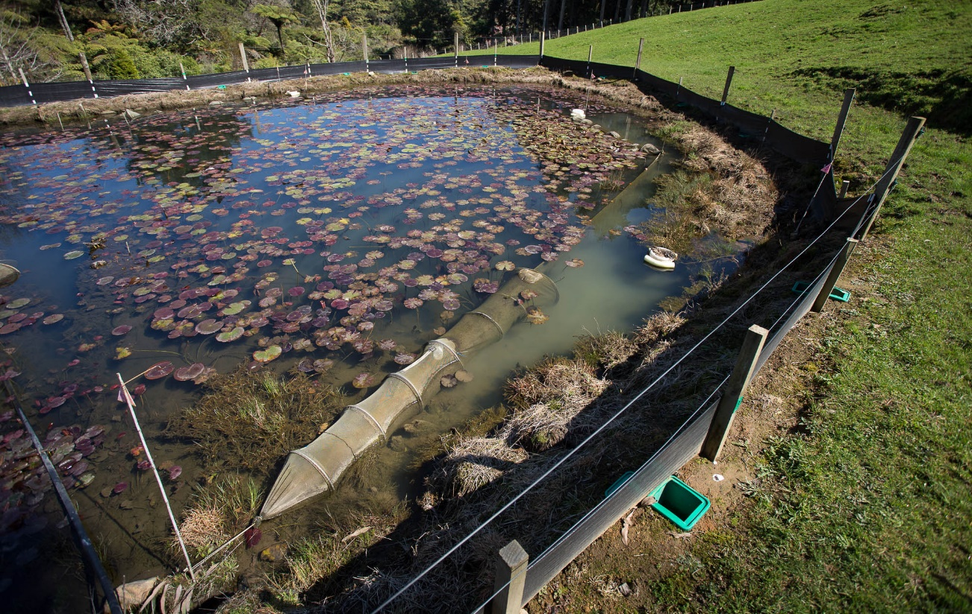
  - Fig. 10. A drift fence with pitfall traps targeting invasive alpine newts in New Zealand. The fence prevents adults from reaching the breeding pond and with traps also on the inside, intercepts any newts enclosed in the pond at the time of fencing. Note also the Fyke nets used to trap aquatic newts and floating funnel traps like those proposed here for cane toad tadpole trapping.
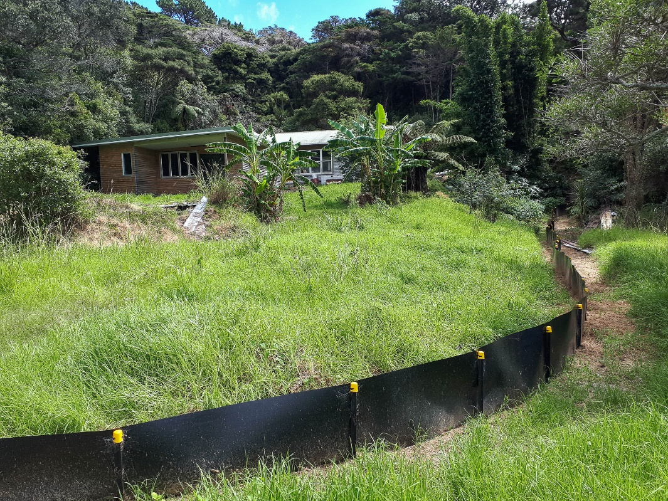
  - Fig.11. A sturdy and long-term barrier fence for the containment of the invasive plague skink in New Zealand.
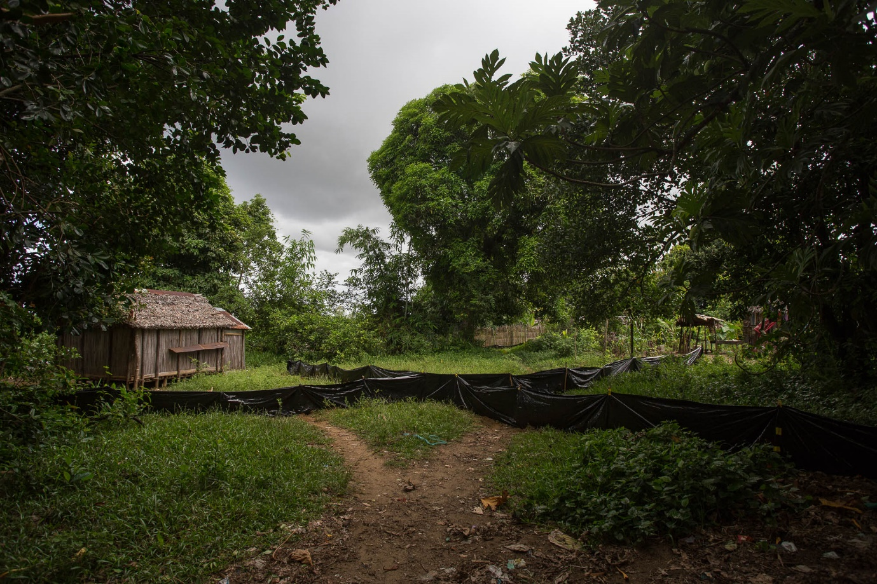
  - Fig. 12. Low cost and low durability drift fences constructed in Madagascar from thin plastic membrane. The fences lasted only a few weeks of wear and tear before needing to be replaced and thus creating unnecessary pollution.
- Fence construction
- Posts: Fence posts can be any material but treated timber stakes or quarter-rounds are probably ideal where they are available. Metal waratahs can be used as can assorted spare timber. Posts will need to be spaced according to the material being used for fencing. More flexible or stretchy materials will need more frequent posts and in high wind zones additional posts will also be needed.
- Barrer: The fence does not need to be elaborate or tall (Fig. 10-12). A 50-70cms fence is enough to deter toads from jumping over. Fence construction materials will depend on availability and the duration of intended use. Lightweight plastic sheeting can be used but this will degrade under UV exposure and ultimately contribute to environmental pollution. For longer-term durability 1.5mm thick HDPE (high density polyethylene as seen in Fig. 11.) membrane can be used but this is expensive and heavy but also a tough material that can last at least 3-5years in harsh conditions. A more modestly priced option but with some durability is weed matting. Rolls of which are relatively inexpensive and usually of at least a meter in width. To be effective it is necessary to bury a section of the fence below the surface of the earth to prevent toads from crawling under the fence. This is achieved by digging a small trench at the foot of the fence into which the lower portion of the fencing material sits like a skirt, to be covered over with soil.
- Pitfall traps: Pitfall traps are buckets sunk into the ground immediately below the drift fence (Fig.6.). They must be flush with the ground so that toads can easily fall into them and placed immediately against the drift fence to ensure toads cannot sneak between the bucket and fence. It is also possible to place the pitfall buckets directly below the fence so that they catch toads from both sides of the fence. This method maximizes toad captures. Buckets need to be at least 50cms deep to prevent toads from jumping out. Buckets should have holes drilled into them to ensure that they can drain freely in the case of heavy rainfall.
- Checking regime: The pitfall traps are live traps and so require daily checking. Toads are predominantly crepuscular and nocturnal so checking traps in the morning is the preferred strategy to prevent toads being exposed to direct sun and high daytime temperatures. To temporarily close the traps, it is best to fill the buckets with climbable vegetation like pieces of palm frond.
Equipment required:
- Fence posts – these can be simple wooden stakes, fencing timber, or any length of material strong enough to hold the fencing material and be able to attach the material.
- Fencing material – For short term use, many materials can be considered but weed matting or similar is probably the best option for low-cost medium-term fencing. For more durable and long-lasting fences 1.5mm thick HDPE (high density polyethylene) membrane can be used but this is both expensive and bulky. Fences can be between 50 and 70cms above the ground and it is important to bury a skirt of the fence to prevent toads from digging underneath.
- Pitfall traps – Buckets are the best pitfall traps but will need to be at least 50cms deep to minimise toads escaping. Drill drainage holes in the bottom of buckets.
- Attachment and fixing – Staples can be used to attach light weight (weed matting) materials to wooden posts. If non-wooden posts are used, then zip ties may be useful. For heavy duty fencing membrane tek screws with large washers are required.
Health and safety:
Use appropriate safety equipment for digging and construction. Skill and care are required when using power tools. Ensure those using them have appropriate experience or training.
References:
Reardon, J. T., Kraus, F., Moore, M., Rabenantenaina, L., Rabinivo, A., & Randrianasolo, H. H. (2018). Testing tools for eradicating the invasive toad Duttaphrynus melanostictus in Madagascar. Conservation Evidence, 15, 12–19.

Hand capture and removal
Hand capture is the easiest, most obvious, and least logistically challenging method for capturing cane toads. Whilst the toads may be encountered opportunistically, toads are most reliably detected at dusk and throughout the night, and especially so if there have been recent rains to elevate the humidity and ground moisture.
For night searching a head torch is ideal, keeping hands free for carrying a container for captured toads. Cane toads can be located by triangulating on their distinctive chirping calls. Cane toads most commonly call from the edges of waterbodies.
It is preferable to work in small teams (Fig. 13), when attempting hand capture. Everyone will search the environment slightly differently so to achieve maximum detection it is good to have more than one individual search an area if possible. Working in small teams is also good for moral.
If cane toads are particularly abundant in each area it will be necessary to have capacity to hold larger numbers of toads for euthanasia. Large drums can be used for this purpose, but it is important that toads are humanely euthanized as soon as possible and not held in containment without food, water, or shelter for more than 2-3hours. Containers should never be in direct sunlight.
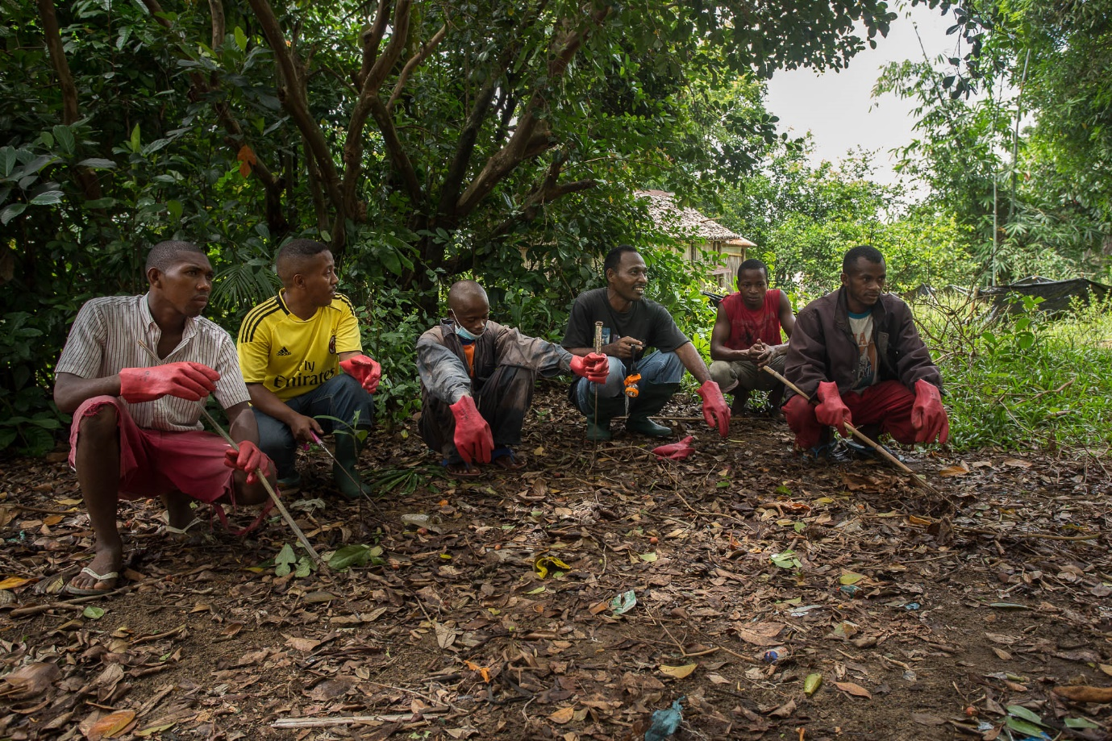
  - Fig. 13. Hand capture team before beginning search in Madagascar for Asian toads.
Equipment required:
- Head torch – necessary for locating toads in the dark. Red head torches can be effective at diminishing disturbance to toads, for example if trying to capture them whilst calling at a breeding pool. White light head torches are more effective for spotting toads in general.
- Bucket – deep enough to prevent toads from jumping out of bucket.
Health and safety:
- Gloves or facilities to wash hands after toad collecting.
- Safety glasses to minimise risk of toad toxin to eyes.
References:
Reardon, J. T., Kraus, F., Moore, M., Rabenantenaina, L., Rabinivo, A., & Randrianasolo, H. H. (2018). Testing tools for eradicating the invasive toad Duttaphrynus melanostictus in Madagascar. Conservation Evidence, 15, 12–19.

Citric acid solution spray
Capturing cane toads by hand requires a certain skill set and for certain habitats, such as those with dense vegetation, the method may be inefficient.
In Hawai’i, techniques have been developed to remove coquí frog (Eleutherodactylus coqui) populations using citric acid sprays with a level of success (Beachy et al. 2011), and this technique is the only easily scalable tool for removing terrestrial amphibians without the need for individual capture or significant habitat alteration. Although some evidence from Hawai’i exists for phytotoxicity of 16% w/v citric-acid solution, impacts on crop health were minimal (Pitt & Sin 2004).
The tool was further developed and tested in Madagascar for the invasive Asian toad (Duttaphrynus melanostictus), a species superficially very similar to the cane toad. Trials of both 16% and 25% citric acid solution proved to be extremely effective at killing toads as a standard method of control (Reardon et al. 2018). This trial demonstrated very high levels of mortality even in dense vegetation with no significant damage to crop plants or vegetation generally.
Citric acid is found naturally in lemons and other citrus fruits. Lemons typically contain about 7% citric acid by mass (weight), so the methods described here use a concentration a little more than double (16%) and triple (25%) that of lemon juice. Here we recommend using the stronger concentration of 25% citric acid solution.
The solution needs to be mixed carefully. To achieve a 25% weight by volume (w/v%) solution, 25 grams of citric acid powder must be mixed with 1000 millilitres (1 litre) of water. This can obviously be scaled accordingly, so mixing up 10 litres of solution would require 250 grams of citric acid powder. Citric acid is very soluble so there shouldn’t be any difficulty in getting the powder to dissolve. Face masks should be worn during mixing to prevent inhalation of citric acid powder, that can be harmful if inhaled.
A backpack sprayer is the most efficient method of deploying the solution at small scale (Fig.14). In trials, the application of 200ml per m² was most effective. Therefore a 10-litre backpack sprayer has capacity to treat 50m²(Reardon et al. 2018).
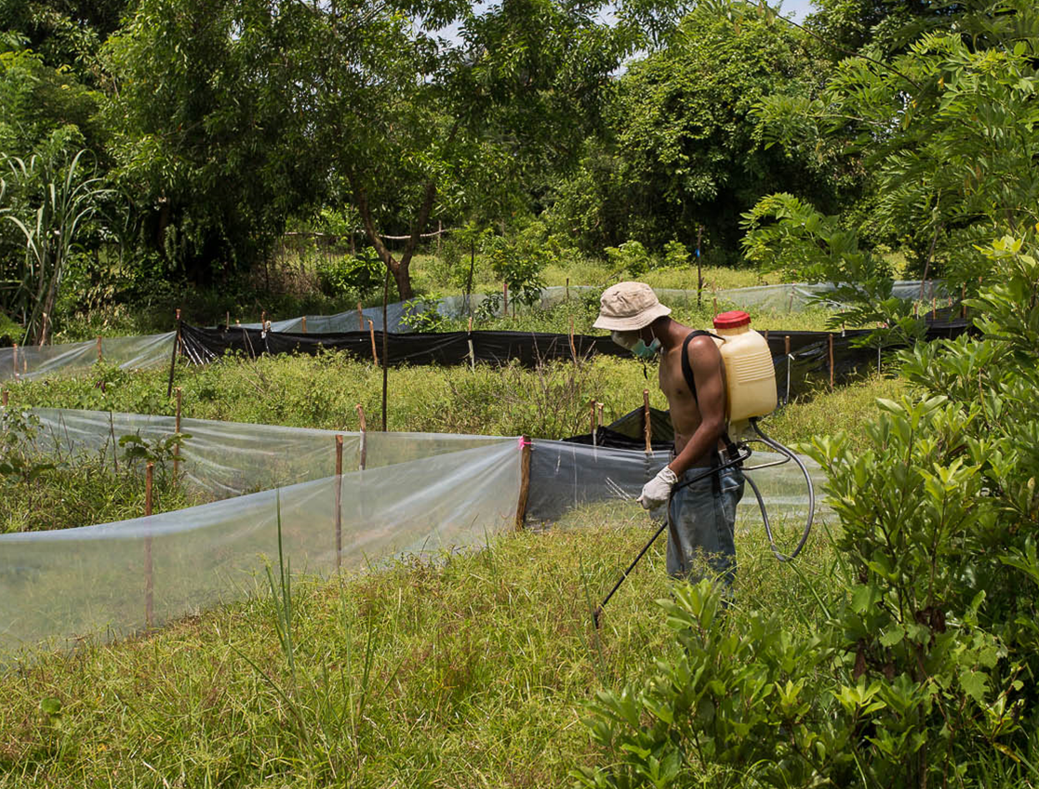
  - Fig. 14. Citric acid solution being sprayed in drift fenced areas for the removal of Asian toads in Madagascar.
Equipment required:
- Weighing scales and receptacle – for measuring out citric acid powder.
- Clean, fresh water – the solution will be compromised if saline or dirty water is used.
- Liquid measuring containers – containers of known litres to allow solution to be made up.
- Stirring utensil – a long handled utensil to achieve mixing.
Health and safety:
- Eye protection – safety glasses or sunglasses to prevent solution splashing into eyes.
- Face mask – when mixing up solution a face mask is essential to mitigate risk of citric acid powder inhalation.
- Gloves or access to washing water – the citric acid solution may be irritant to sensitive skin. Any accidental exposure to the solution should be washed off promptly.
References:
Beachy J.R., Neville R. & Arnott C. (2011) Successful control of an incipient invasive amphibian: Eleutherodactylus coqui on O’ahu, Hawai’i. Pages 140–147 in: C.R. Veitch, M.N. Clout & D.R. Towns (eds.), Island invasives: eradication and management. IUCN, Gland, Switzerland.
Pitt W.C. & Sin H. (2004) Testing Citric Acid Use On Plants. USDA National Wildlife Research Center – Staff Publications, 377.
Reardon, J. T., Kraus, F., Moore, M., Rabenantenaina, L., Rabinivo, A., & Randrianasolo, H. H. (2018). Testing tools for eradicating the invasive toad Duttaphrynus melanostictus in Madagascar. Conservation Evidence, 15, 12–19.

Tadpole trapping
Cane toads, being amphibians lay long strings of eggs into fresh and brackish water. Cane toads can lay thousands of eggs (Fig. 15), in a breeding event and without natural predators, their young can survive and cause a very rapid population explosion. Whilst it is preferable to prevent breeding through the removal of water bodies or fencing them off from toads, there are strategies to reduce recruitment from tadpoles. Cane toad eggs release a chemical which attracts other cane toad tadpoles who predate on the eggs. Researchers discovered that the toxins secreted from the parotid glands of the toads replicate the ‘smell’ of the eggs and so can be used as a bait which is placed in a simple funnel-type trap to trap tadpoles (Crossland and Shine 2011; Crossland et al. 2012). The cane toad tadpoles swim into the trap and can’t swim out. Tadpoles are then euthanised by putting into the fridge for 12 hours, then putting into the freezer. NOTE: the use of toad toxins as a lure for Asian toads is still not proven effective (2023).
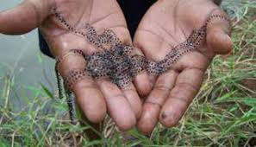
  - Fig. 15. Cane toad eggs
Cane toad tadpoles can stay in tadpole form for a long time, between 3–20 weeks. Trapping tadpoles before they metamorphose can be an extremely effective way of removing an entire generation of toads from the area of focus, especially if breeding water bodies are limited.
Cane toads are poisonous at all life cycle stages. For this reason, it is important to dispose of the euthanised tadpoles in a place where they can’t be ingested by other animals.
Tadpole traps are now widely used in the control of cane toads, but it is important to understand that they are unlikely to remove all tadpoles from a given waterbody. The toxin is also only attractive to larger tadpoles meaning that if trapping is only conducted for a brief period and there has been recent toad breeding many tadpoles will be missed by this technique.
There is a useful report published by Brisbane City Council (BCC 2018) that provides useful and interesting additional information.
Tadpole trap:
Tadpole traps are constructed of watertight plastic containers which are fitted with several inverted and perforated funnels to allow tadpoles to enter (Fig. 16). The traps have funnels placed as low as possible to allow their use in shallow water. Funnels can be glued into place or with zip ties. Plastic often shatters when cut so the use of a soldering iron to melt the plastic may be useful. Always ensure that if using the soldering iron method that work is done in an open and well-ventilated area and the operator avoids inhaling the fumes. A facemask is advised.
Traps should have floats fitted to keep them from sinking and thus losing the trapped tadpoles. Traps should also be anchored to fixed objects, so they are not lost.
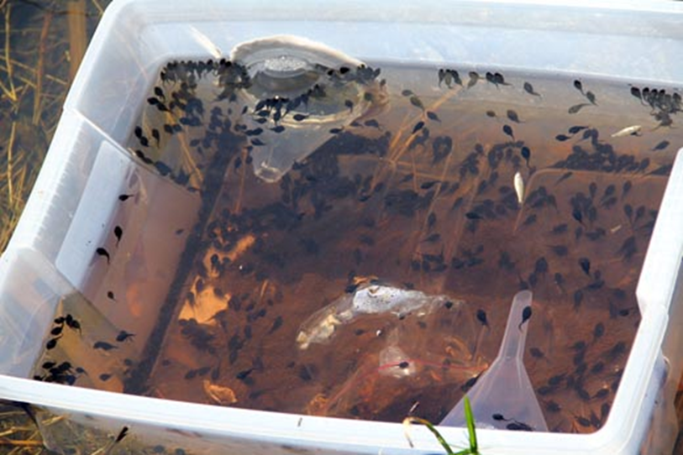
  - Fig. 16. A tadpole trap full of cane toad tadpoles (from: frogwtch.org.au).
Toxin lure:
Whilst commercial lure for cane toad tadpoles are available (https://watergumcommunity.myshopify.com/products/cane-toad-tadpole-lures ) toad toxin collected from the parotid glands work extremely well and can be collected from toads euthanized. Once a toad is humanely euthanized in accordance with the methods outlined in this document, the secretions of the parotid gland can be squeezed onto a glass slide or similar for introducing to the tadpole trap (Fig.17). It is important that eye and face protection is worn during this procedure and gloves are worn. Any toxic secretion that gets in contact with skin should be washed off immediately.
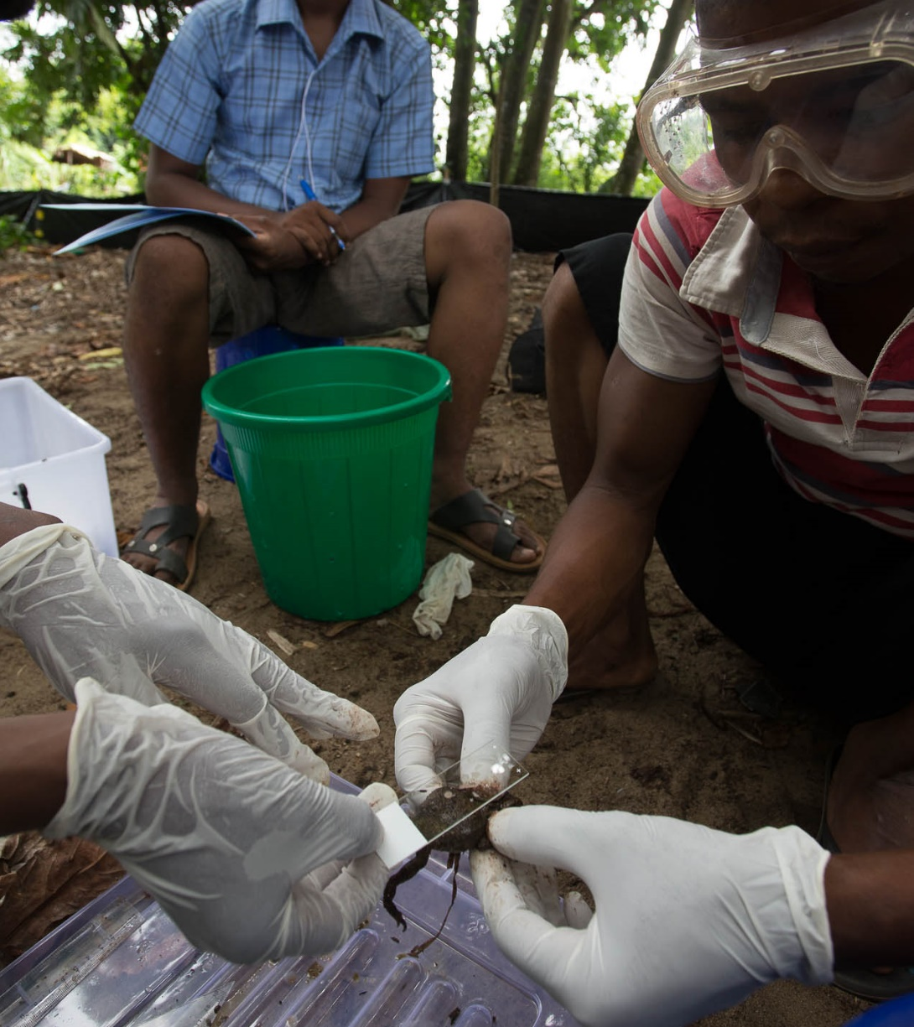
  - Fig. 17. Collecting parotid gland secretions to lure tadpole traps in Madagascar for Asian toads.
Once the lure is in the trap the traps should be placed in the target waterbody, secured using rope or string and then retrieved within 24hrs (Fig.18). Ideally traps are set in the morning and retrieved in the evening for redeployment the next day. Fresh lure should be used on each deployment of the trap. When emptying the traps, to avoid spilling tadpoles back into the environment, empty the tadpole trap through a fine mesh or net.
Tadpoles caught in the traps should be chilled in refrigerator for 12hrs then frozen. The dead tadpoles can them be disposed of though deep burial or incineration.
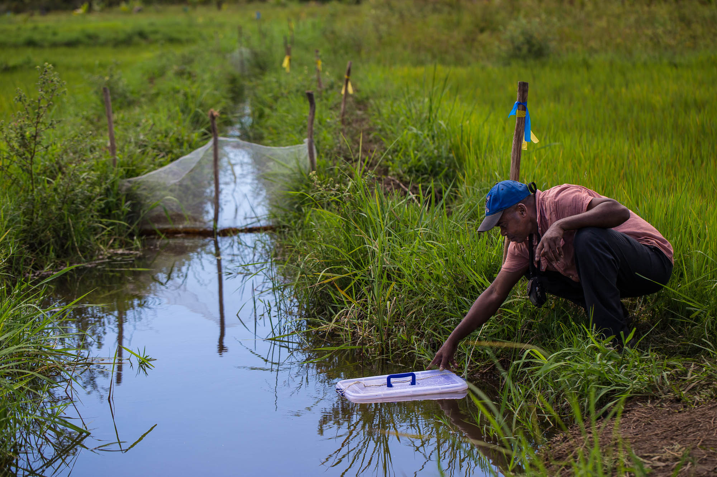
  - Fig. 18. Asian toad tadpole traps being deployed in Madagascar.
Equipment required:
- Plastic container and funnels.
- Zip ties or glue to attach funnels to container.
- Floats to prevent the trap from sinking.
- Cord or similar to anchor the trap and prevent loss.
- Glass slides or similar material for collection of toxin lure for placement in trap.
Health and safety:
- Eye protection – safety glasses or sunglasses to prevent toxins splashing into eyes.
- Face mask – or face shield, to prevent parotid toxin getting into eyes, mouth or on face.
- Gloves and access to washing water – should toxin get on skin it should be quickly washed off.
References:
Brisbane City Council (2018). Cane toad tadpole trapping project (ecosure.com.au) https://imb.uq.edu.au/files/25443/Brisbane_City_Council_Ecosure_Cane_Toad_Trapping.pdf
Crossland, M. R., & Shine, R. (2011). Cues for cannibalism: cane toad tadpoles use chemical signals to locate and consume conspecific eggs. Oikos, 120(3), 327-332.
Crossland, M. R., Haramura, T., Salim, A. A., Capon, R. J., Shine, R. (2012) Exploiting intraspecific competitive mechanisms to control invasive cane toads (Rhinella marina). Proceedings of the Royal Society. doi: 10.1098/rspb.2012.0821.

Toadinator trap
The toadinator trap may be a useful tool as a component of an eradication effort. Details of the tool are provided in section 5.1.4 above.

Removal of waterbodies
Standing water provides for the breeding needs of cane toads. Where possible those waterbodies should either be removed completely or managed so that cane toads cannot gain access.
This approach is obviously limited by the type of environment in which toads require control or eradication. In environments where standing freshwater or brackish water are limited, such as on small atoll type islands with a limited freshwater lens, removal of water bodies may be achievable.
Preventing small water bodies:
In anthropogenic environments items such as discarded car tires, old containers or water tanks can function as breeding waterbodies for toads. Removing such water sources and tidying the environment consequently can reduce breeding opportunities.
Draining water bodies:
Where standing water is accumulating it may be possible with minimal earth works to open a channel using hand labour to allow the water to drain away.
Filling in or ‘capping’:
Depressions that cannot be drained effectively may need to be filled in and capped. This involves first attempting to drain the area. Then fill material is brought in to fill the area so that a low mound is formed, which prevents water from pooling in future. If done at a very small scale this can be achieved with hand labour, but if larger waterbodies are being tackled, an excavator and earth moving equipment may be required.

Detector dogs
Dogs have very sensitive senses of smell, and this ability can be harnessed to detect animals in the environment. Whilst all dogs have this ability there are some very specific dog handling and training skills required before the benefits of a detector dog can be realised.
The development of detector dogs needs skilled handlers and long-term commitment to both train and maintain a working dog. Therefore, the tool is only appropriate where those skills can be developed and maintained.
However, if a commitment is being made to eradicate cane toads from an island, and the eradication is likely to have to deal with issues of detectability of single individual toads, a detector dog may be a sensible option to investigate. The details of how to train and operate a detector dog are too complex to fit in this section. It is advised that those interested contact professional detection dog trainers in the region.

Eradication strategy
The tools described above need to fit within a carefully developed strategy to become an effective eradication plan. It is critical that the planning of any eradication operation is guided by established principles of eradication feasibility and viability. There is a great deal of literature to assist in eradication planning. A good starting point is the resources page of the Pacific Invasives Initiative:
http://www.pacificinvasivesinitiative.org/Resources.html
Whilst the focus of the examples are not toads, the principles are highly transferable.

Data management and reporting
For all eradications, data management and reporting will be critical components of success. It is essential that toad capture data be collected that record the location, date and number of individuals removed. These data can be transformed into metrics such as ‘Catch Per Unit Effort’ or ‘CPUE’ which will be a vital metric in measuring progress. Mapping of the incursion area and the effort expended across the tools employed is an essential component of reporting. The reporting of project progress allows the eradication team and those supporting it to make evidence-based decisions on what techniques are working well, where effort has been expended and areas requiring more effort. The careful curation of data and regular reports will also be vital in evaluating eventual outcomes, either bolstering our understanding of successful methods or describing accurately those that fail, so that future eradication efforts can be improved.

